GAS EXCHANGE REVISION

Q 34 WACE 2014

The diagram below illustrates a particular site in the respiratory system.

A

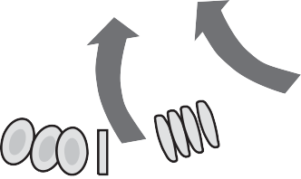

B

1. Identify the structures labelled A and B. (2 marks)
2. The arrows on the diagram show a very important life-sustaining process occurring at this site.
   1. Name and describe the process, which is shown by the arrows on the diagram.

(3 marks)

* 1. List **three** features of the structures shown in the diagram that allow them to carry out this process. (3 marks)

1. Examine the list of events below. A: The diaphragm relaxes

B: The chest cavity increases in volume

C: The chest cavity decreases in volume

D: Air pressure in the chest cavity decreases E: Air moves out of chest cavity

F: The diaphragm contracts

G: Air moves into the chest cavity

H: Air pressure in the chest cavity increases I: The diaphragm moves upward

J: The diaphragm moves downward

Using the letters provided for each event, choose those that occur during inspiration (breathing in) and list them in the correct order. (1 mark)

# WACE 2013

# Question 40 (20 marks)

1. Outline the pathway taken by air from outside the body through the human respiratory system to the point where gas exchange occurs. (7 marks)
2. The respiratory surface in the lungs is designed to maximise gas exchange.

Identify and explain **three** features of the lung’s respiratory surface that allow for maximum gas exchange. (6 marks)

1. Breathing is an essential component of life. Explain the importance of breathing and describe the process of expiration. (7 marks)